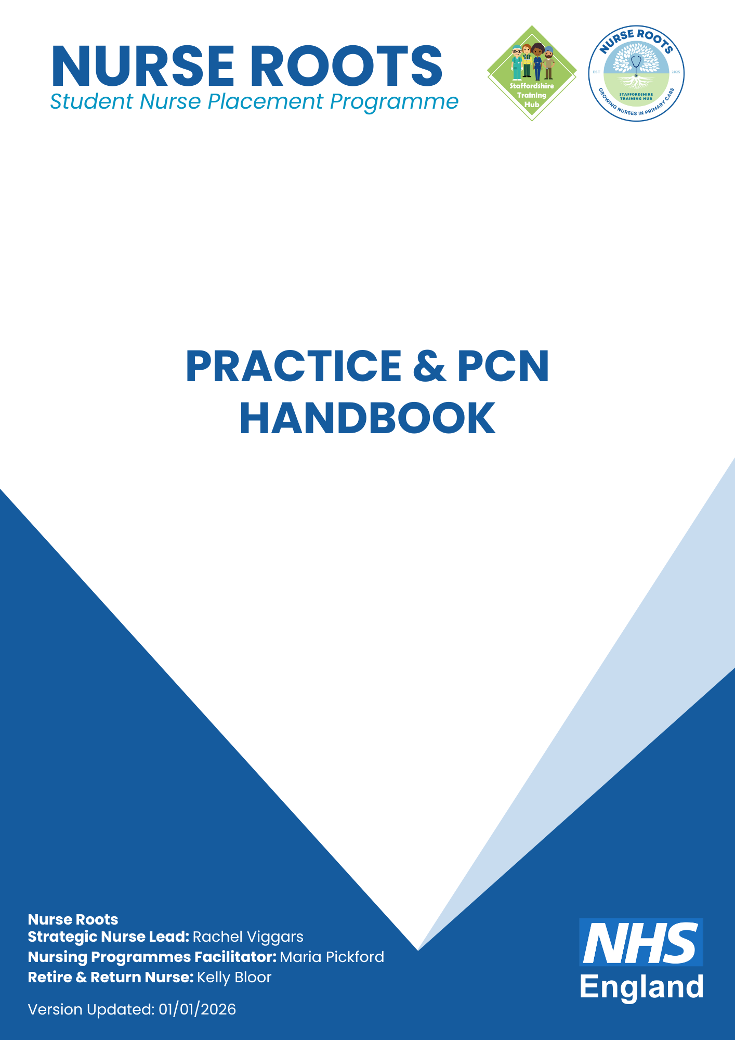

Contents

Programme Overview 3
Welcome 3
Why Nurse Roots Matters 3
How the Hybrid Placement Model Works 3
Benefits for Practices & PCNs 4
Early impact 4
STUDENT EXPECTATIONS 5
ROLES AND RESPONSIBILITIES 5
Actions for practices 5
PRACTICE QUALITY ASSURANCE ASSESSMENT 6
Introduction 6
Organisation Details 6
Personal Details 7
Constituent Placement CQC Information 7
STH Quality Assurance Process 8
General Information and Declarations 9
Placement Practice Supervisor and Practice Assessor Information 11
SSSA- Standards for Student Supervision and Assessment 12
Process for Practice Staff to escalate concerns regarding trainee GPNs 13
Process for escalating concerns and who to involve: 13
Placement resolution protocol for Practice concerns: 14
Contact Information 14
Learning Agreement 15
Practice or PCN Declaration 15
PRACTICE GUIDANCE 16
Supervision & Safety 16
Placement Area Responsibilities 16
Competence & Training 16
Competency and Training Requirements 16
Patient Group Directions (PGDs) 17
Patient Specific Directions (PSDs) 17
Student-Led Clinic Opportunities 17
Levels of Supervision 17
Working Within Competence 18
Documentation & Accountability 18
Student Nurse Project Work 18

Nurse Roots Student Placement

Programme Overview

Welcome

Nurse Roots is a hybrid primary care placement programme for pre-registration nursing students from local universities. It offers a rich, supportive introduction to General Practice Nursing (GPN) and showcases primary care as a rewarding first-destination career.

Why Nurse Roots Matters

As more care shifts from hospital to community settings, it is vital that student nurses experience primary care early in their training. Nurse Roots helps to:
- Increase exposure to General Practice as a first-destination career.
- Address challenges faced by an ageing nursing workforce with recruitment and retention pressures.
- Challenge the perception that nurses must work in hospital settings before moving into General Practice.
- Highlight the complexity, autonomy and public health impact of the GPN role.

How the Hybrid Placement Model Works

The Nurse Roots placement model has been designed to reduce pressure on practices while providing students with a high-quality, holistic learning experience in primary care.
- Practice days in GP surgeries [typically 2.5 days per week] – Students gain insight into the role of the General Practice Nurse and wider primary care team.
- Role-specific education sessions –teaching focused on GPN practice, such as long-term conditions, immunisation and screening programmes.
- Restorative Clinical Supervision – Professional Nurse Advocate (PNA) led sessions to support student wellbeing during placement.
- Local priority work – Students support practices with agreed areas of service delivery and locally identified priorities.
- Insight days – Visits to supporting voluntary and charity organisations to better understand population health needs, services and referral pathways.
- Project work – Students develop and implement a project in health promotion, quality improvement, or a topic agreed with the practice.
- Access to Training Hub courses – Opportunities to attend free Staffordshire Training Hub courses during the placement.

Benefits for Practices & PCNs
- Workforce development: support aspiring general practice nurses and strengthen future workforce pipelines.
- Staff development: mentoring students enhances leadership, supervision and teaching skills within the team.
- Future recruitment: positive placement experiences encourage students to seek employment locally upon qualification.
- Enhanced service delivery: students contribute to clinics, health promotion and project work within their scope.
- Reduced supervision burden: GPN facilitators and retire & return nurses support supervision and PAD completion.
- Financial contribution: practices receive payment for hosting students and may benefit from increased service provision. The 25/26 tariff for student nurse placement is £145.00 based on FTE. Staffordshire Training Hub will invite invoice completion once the placement has ended via email to the practice manager.
- System-wide links: strengthens relationships across the wider local health and care system.

Early impact

The nurse roots model was piloted in June 2025 in collaboration with North Staffordshire GP Federation, offering placements to pre-registration nursing students from Keele university and Staffordshire university.
- 9 students took part in the initial pilot, of which, 5 students secured roles within the Staffordshire GPN Foundation School upon qualification and are now working in local Practices.
- Practices reported fresh energy, insight and valuable contribution from students within their teams.

This is a promising start and demonstrates the programme’s potential to contribute directly to the GPN workforce pipeline and help meet system-wide workforce needs.
Future cohorts will also include those from Derby and Wolverhampton Universities and placements will be offered within all regions of Staffordshire.
Quality improvement work will continue to be developed and implemented by students, enhancing their learning experiences while also increasing the positive impact on practices and patient care.

Practice/PCN and Student Testimonials can be found here.

STUDENT EXPECTATIONS

- Be proactive in seeking and engaging with learning opportunities throughout the placement.
- Participate in shared learning and contribute positively to team activities.
- Work within their level of knowledge, skills, and competence, recognising their limitations and seeking supervision or support when required.
- Ask for feedback, reflect on it, and value its importance in their learning and development.
- Raise any concerns in a timely manner, so they can be appropriately addressed and escalated if necessary.
- Act professionally at all times, including being punctual, maintaining confidentiality, and adhering to infection prevention protocols (e.g. bare below the elbow).
- Read, understand, and adhere to the Student Guidance for the duration of the placement.
- Wear their uniform and I.D. at all times.

ROLES AND RESPONSIBILITIES

The table below provides an overview of the key roles and responsibilities of the main stakeholders involved in the school. The list is not exhaustive.
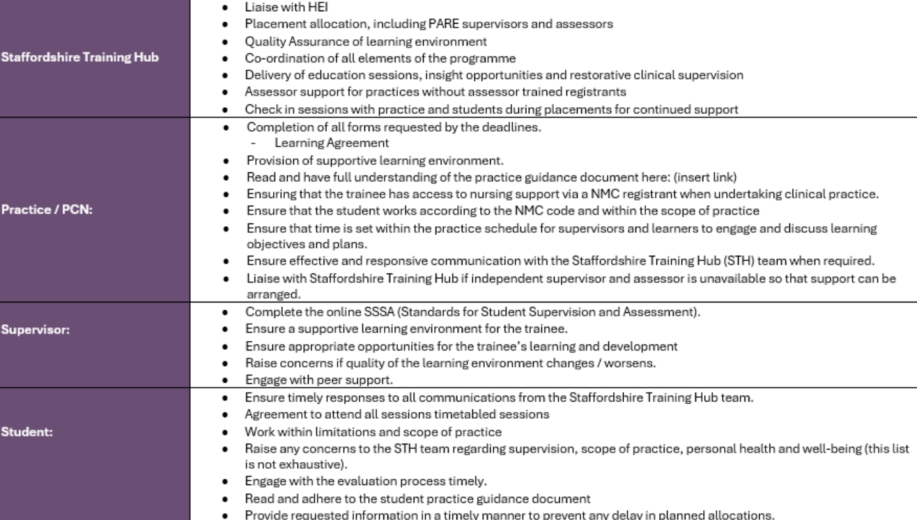

The STH Team are available to support and provide guidance to all those involved in the programme.

Actions for practices

Quality Assurance | Page 6 | Return to Training Hub at traininghub@gpfirst.net
Learning Agreement | Page 14 | Return to Training Hub at traininghub@gpfirst.net

PRACTICE QUALITY ASSURANCE ASSESSMENT

For Office Use:
PREPARED BY | Rachel Viggars | TITLE | Strategic Nurse Lead | DATE
APPROVED BY | <enter text> | TITLE | <enter text> | DATE | <enter text>

Introduction

There is wide acknowledgement of practice experience being of prime importance in the educational preparation of student undertaking health and social care programmes. The provision of high-quality placements is seen as a partnership responsibility between the providers of care and the providers of education. Allied to these responsibilities is the requirement to monitor and ensure the quality of placement experiences. This is to be achieved through a collaborative approach to the auditing of practice placements against standards and guidelines laid down by relevant authorities to ensure, enhance and develop the quality of practice placement provision.

Information gathered within this document is pertinent to the Staffordshire Training Hub Nurse Roots programme and support the elements of education and supervision within the training Practices.

Organisation Details

Please complete all of the sections:
Name of Applicant Organisation  e.g. primary care network, practice, OOH provider | <enter text>
Date of Application | <enter text>
Name of base / host Practice | <enter text>
Name(s) of Constituent Placements  e.g. practices, pharmacies, care homes (if different from above)  NB Please include ODS code for GP practices | 1) <enter text>  2) <enter text>  3) <enter text>  4)<enter text>
Date of Recognition assessment  (To be arranged as a Practice visit with the STH team) | <enter text>
Assessors | <enter text>

Personal Details

Lead individual completing the form on behalf of the organisation. These details will be stored as the lead contact for this organisation.
Name | <enter text>
Email Address | <enter text>
Role in the PCN / Practice | <enter text>

Constituent Placement CQC Information

Name of Constituent Placement | Date of most recent CQC rating | Scoring across all 5 standards | Any previous CQC ratings below ‘Good’?
 | Provide CQC link if possible | (Must be rated ‘good’ in all) | (Please list actions taken)
<enter text> | <enter text> | <enter text> | <enter text>
<enter text> | <enter text> | <enter text> | <enter text>
<enter text> | <enter text> | <enter text> | <enter text>
<enter text> | <enter text> | <enter text> | <enter text>
<enter text> | <enter text> | <enter text> | <enter text>

STH Quality Assurance Process

The form collates information to document...

General Information and Declarations

- With which HEIs (universities) are you affiliated? This may include nurses, AHPs and medical students:

☐ University of Staffordshire
☐ Keele University
☐ University of Wolverhampton
☐ Birmingham City University
☐ University of Derby
☐ Other – please state:

- Are you a GP Training Practice?

☐ Yes
☐ No

- Are you an approved Practice to support pre-registration Student Nurses?

☐ Yes
☐ No

- What is the name of your nurse education lead?
<enter text>

- Please provide the names of ALL educators (including nurses, AHPs and GP educators) involved in teaching and learning within the organisation:

Educator name: | Please specify who they educate:
<enter text> | <enter text>
<enter text> | <enter text>
<enter text> | <enter text>
<enter text> | <enter text>
<enter text> | <enter text>
<enter text> | <enter text>
<enter text> | <enter text>
<enter text> | <enter text>
<enter text> | <enter text>
<enter text> | <enter text>

- What is your current placement provision? Please list the number and type of ALL learners that your organisation currently hosts, including stage:

e.g. 1 x ST1 (current in hospital role), 1 x ST3, 2 x nurses 8-week placements 4 x a year etc

Learner Type/Profession | Training stage  e.g. GPST1-3 or, Student Nurse (year 2-3), etc. | No. Learners  (WTE) | Additional Information
<enter text> | <enter text> | <enter text> | <enter text>
<enter text> | <enter text> | <enter text> | <enter text>
<enter text> | <enter text> | <enter text> | <enter text>
<enter text> | <enter text> | <enter text> | <enter text>
<enter text> | <enter text> | <enter text> | <enter text>
<enter text> | <enter text> | <enter text> | <enter text>
<enter text> | <enter text> | <enter text> | <enter text>
<enter text> | <enter text> | <enter text> | <enter text>
<enter text> | <enter text> | <enter text> | <enter text>
<enter text> | <enter text> | <enter text> | <enter text>
<enter text> | <enter text> | <enter text> | <enter text>

Roles and Responsibilities of Supervisors and Assessors

All Practice Supervisors and Assessors must follow the NMC Standards of Student Supervision and Assessment (SSSA) and the NMC documents are available via the following links: NMC: Standards for Supervision and Assessment , NMC: Introduction to our Standards of Student Supervision and Assessment

Further NMC information for Practice Supervisors is available here: NMC: What do practice supervisors do?

Standards for Student Supervision and Assessment (SSSA) Training
If you need to complete the SSSA training please see the following links for all aspiring or current Practice Supervisors [PS] and Practice Assessors [PA] to use:

Initial Training
PS Training: Practice Supervisor Preparation Training
PA Training: Practice Assessor Preparation Training

Practice Supervisor & Assessor [Single or Joint course training]
Online Practice Supervisor/Assessor courses and updates - ARU

Update Training
PS/PA Update Training: Learning In Practice Update

Please contact the Staffordshire Training Hub directly for information or support on SSSA initial or update training.

Role and responsibilities of Practice Supervisor

The aim of the Practice Supervisor role is to support new GPNs whilst they are on placement in clinical practice. This supervision will initially be undertaken by working with the new GPN in shared clinics, but as capability and confidence improves, by more indirect supervision, for example debrief sessions following their own clinics and by easy assessibility of guidance and advice during clinic times. The first month in clinical practice will be on a supernumerary basis to enable a comprehensive induction process.

Role and responsibilities of Practice Assessor

The Practice Assessor takes on the responsibility for the final sign off of clinical competencies. In order to assess each foundation nurse on an individual basis, please schedule time for an initial, interim and final discussion/interview. This could be undertaken by the Practice Supervisor and fed back to the Assessor if need be.

Please ensure that the foundation nurses shares with you a copy of the University documents and that time is allocated to review progress on a weekly basis. This will assist with completion of the skills and competencies documentation required for the Universities and to offer continuing support and clinical supervision.

Placement Practice Supervisor and Practice Assessor Information
Please provide your current practice supervisor and assessor inFORMATION

Name of Supervisor | Field of Nursing | Name of Practice Assessor | Field of Nursing | PIN Check | Evidence of Prior Training | Date of last SSSA update | Initial SSSA required (Y/N)
Text. | Text. | Text. | Text. | Text. | Text. | Text. | Text.
Text. | Text. | Text. | Text. | Text. | Text. | Text. | Text.
Text. | Text. | Text. | Text. | Text. | Text. | Text. | Text.
Text. | Text. | Text. | Text. | Text. | Text. | Text. | Text.
Text. | Text. | Text. | Text. | Text. | Text. | Text. | Text.
Text. | Text. | Text. | Text. | Text. | Text. | Text. | Text.

SSSA- Standards for Student Supervision and Assessment

These standards set out the roles and responsibilities of practice supervisors and assessors, and how they must make sure students receive high-quality learning, support and supervision during their practice placements. They also set our expectations for the learning, support and supervision of students in the practice environment. As well as setting out how students are assessed for theory and practice learning.

Practice supervisors and assessors should use these standards to ensure the best possible learning experience for students.

Some useful resources and more information can be found below:
Please click here for an explanation video on SSSA

Midlands, Yorkshire & East Practice Learning Group [MYE SSSA] NMC Standards for Supervision & Assessment and resources, including student nurse primary care proficiencies.

IF SSSA IS REQUIRED, PLEASE ADD SUPERVISOR / ASSESSOR NAME AND CONTACT DETAILS BELOW:

Name of Supervisor | Email Address | Contact Telephone Number
<enter text> | <enter text> | <enter text>
<enter text> | <enter text> | <enter text>
<enter text> | <enter text> | <enter text>
<enter text> | <enter text> | <enter text>
<enter text> | <enter text> | <enter text>
<enter text> | <enter text> | <enter text>

Process for Practice Staff to escalate concerns regarding Student Nurses

While it is expected that the students will successfully complete their placement, there may be occasions where they are not making expected progress, there are concerns about their health and wellbeing, or there are concerns about their conduct or attendance.

This document provides an overview of the steps to be taken in practice and by the STH to develop the necessary action plans to support a student’s achievement or provide health and wellbeing support, or to investigate allegations in respect of a student’s conduct.

Key Staff:

The staff most closely involved in the raising and management of concerns are:
- Practice Supervisor (PS)
- Practice Assessor (PA)
- Practice Manager (PM)
- Staffordshire Training Hub, Nursing Programmes Facilitator (NPF)
- GPN Facilitators / Educators / Retire & Return PCN nurses (GPNF/GPNE/R&R)
- Academic Lead (Nursing Programme) (HEI)

Process for escalating concerns and who to involve:

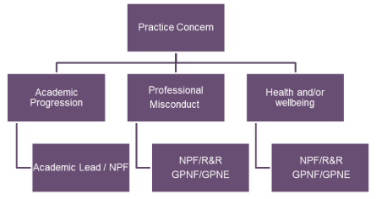

Placement resolution protocol for Practice concerns:

Contact Information

Nursing Programmes Facilitator | Maria Pickford | Maria.pickford@gpfirst.net
Nursing Programmes Facilitator Hours: | Tuesdays: 0830-1630, Thursdays: 0800-1100, Fridays: 0830-1700
Programme Provider | Staffordshire Training Hub | traininghub@gpfirst.net  01785 747373
Strategic Nurse Lead | Rachel Viggars | Rachel.Viggars2@staffs.nhs.uk

Learning Agreement

This document acts as a contract between the Practice / PCN and the Staffordshire Training Hub regarding the following training programme application:

Trainee Name: | <enter text>
Course Title: | Nurse Roots: Student Nurse Placement Programme
Training Start and End Date: | <enter text>
Placement Hours: | <enter text>
PCN: | <enter text>

Practice or PCN Declaration

To confirm that you are able to host a student nurse and fulfil the placement requirements, please complete the check boxes and sign the below:

☐ | We will fully support the allocated student nurse to complete the agreed clinical placement hours in accordance with the placement agreement and university requirements.
☐ | We confirm that we have read and understand the guidance for safely supporting student nurses in practice, as outlined in the Practice Guidance on pages 15-17 of this Practice and PCN handbook.
☐ | We confirm that the student nurse will be supported and supervised in accordance with the NMC Standards for Student Supervision and Assessment (SSSA) and that appropriate nursing supervision will be provided throughout the placement to enable the student to safely achieve their required learning proficiencies.
☐ | We will liaise with Staffordshire Training Hub should we require any supervisor and/or assessor support, updates, or training information.
☐ | We will promptly contact Staffordshire Training Hub regarding any concerns, incidents, or difficulties relating to the allocated student nurse, including issues related to supervision, conduct or attendance.
☐ | We confirm that appropriate governance arrangements are in place, including safeguarding, information governance, incident reporting, and health and safety policies, to support student placement activity.
☐ | We will ensure that any access to clinicial systems (e.g. EMIS/SystemOne) is appropriate to the student’s role, time-limited, supervised, and compliant with information governance requirements.
Full Name: | <enter text> | Job Title: | <enter text> | Date: | <enter text>
Action Required: | Please e-mail fully completed learning agreement to the Staffordshire Training Hub at traininghub@gpfirst.net

PRACTICE GUIDANCE

Supervision & Safety

- Students must ALWAYS have appropriate direct or indirect supervision.
- Students must work strictly within their assessed competence.
- Supervisors are responsible for safe delegation; students are responsible for acknowledging their limits.
- Students always remain supernumerary and must have an appropriately trained member of staff during practice hours.

Placement Area Responsibilities

Placement providers must:
- Deliver a clear local induction, including escalation structures, emergency procedures, sickness reporting procedures and medicines-related policies.
- Ensure students always have appropriate supervision.
- Provide learning opportunities aligned with programme expectations and the student's stage of training.

Ensure students do not undertake any task for which they have not received training and formal assessment of competence.

Competence & Training

Students must not undertake any task they have not been:
✔ Taught
✔ Practically trained in
✔ Formally assessed as competent to perform
- Skills require direct supervision until competence is reliably demonstrated by the practice supervisor/assessor.
- Students must escalate if they feel unprepared, unsafe, or pressured to perform a task.

Competency and Training Requirements

Students must have:
- Sufficient theoretical teaching prior to practice exposure.
- Clinical skills training using simulation or supervised practice before patient-facing attempts.
- Formal assessment of competence by a suitably qualified supervisor before undertaking a task especially invasive or medicines-related tasks.
- Years one and two students require direct supervision at all times.
- Year three students can have indirect supervision when assessed to be appropriate as above.

Patient Group Directions (PGDs)
- Students MUST NOT work under PGDs (PGDs apply only to registered professionals)

Patient Specific Directions (PSDs)
- Students may administer medication ONLY under a valid PSD for the specific patient on that day.
- The student needs to be named on the PSD and it saved in the patient record prior to administration
- Appropriate supervision must match the student’s competence and local policy.

Students must be confident in:
- the medication
- the reason for administration
- contraindications
- side effects
- Students must never administer medicines without a clear, contemporaneous PSD.
- Students are not permitted to administer immunisations under PSD’s or PDGs (this is local and national guidance).

Student-Led Clinic Opportunities

We anticipate that, after several weeks in practice and following an assessment confirming that they are confident and competent in the required tasks, students will be able to work under indirect supervision for short student-led clinic opportunities. Appropriate clinic opportunities will depend upon their individual proficiencies, confidence and local policy.
Observation and direct learning opportunities also remain fundamental components of the placement.

Levels of Supervision

Direct Supervision: Supervisor present and observing; required for new or high-risk skills.
Close/Indirect Supervision: Supervisor nearby on site; used only once competency is demonstrated.
Unsupervised practice is not permitted for student nurses.

Working Within Competence
Students must:
- Only undertake skills they have been trained and assessed to perform.
- Escalate immediately if they feel unprepared or unsafe.
- Never perform tasks because of staffing pressure or expectation.
- Seek supervision when unsure the responsibility for safe practice sits with both the student and the supervisor.
Examples of what the student may do:
- Weight checks and BMI’s
- Lifestyle advice
- Phlebotomy (if competent)
- Blood pressure checks
- B12 injections (if competent and named on PSD)
- Home blood pressure recording

Documentation & Accountability
- Students must clearly identify themselves and follow local rules on countersigning documentation.
- Supervisors remain accountable for decisions about delegation, supervision, and the student's involvement in care.
- Students remain accountable for acknowledging their own limitations.
- Students must not make notes under another professionals log in without the supervision and second check by that professional.
- Students may only access clinical computer systems after completing full training and using their individually assigned login credentials [provided by Staffordshire Training Hub]. Sharing login details is strictly prohibited, as it may result in breaches of GDPR and patient confidentiality.

Student Nurse Project Work

During their placement, student nurses will complete a project to apply their learning, improve understanding of health topics, and develop communication skills with patients and the healthcare team. Projects may include presentations, patient leaflets, health promotion stands, or videos, and can focus on topics such as smoking cessation, blood pressure home monitoring, weight management, or a custom topic agreed with the practice.

Practices are invited to suggest priority areas or health promotion initiatives that would benefit their patients, enabling students to support meaningful work within the practice. Students will use timetabled non-practice day hours to work independently and will have the opportunity to showcase or present their work at a final session. This is intended to be a shared, engaging learning experience that promotes patient education, best practice, and quality improvement.

